CS5542 Big Data Apps and Analytics

LAB ASSIGNMENT #2

REPORT and SCREEN SHOTS

**1. R Project**

**Prepare a dataset and perform k-means clustering.**

The diabetes data set is taken from the UCI machine learning database repository at:

<http://archive.ics.uci.edu/ml/datasets/Pima+Indians+Diabetes>

1. We LOAD the data into R using the file.choose() method and read csv file into Dataframe in R.

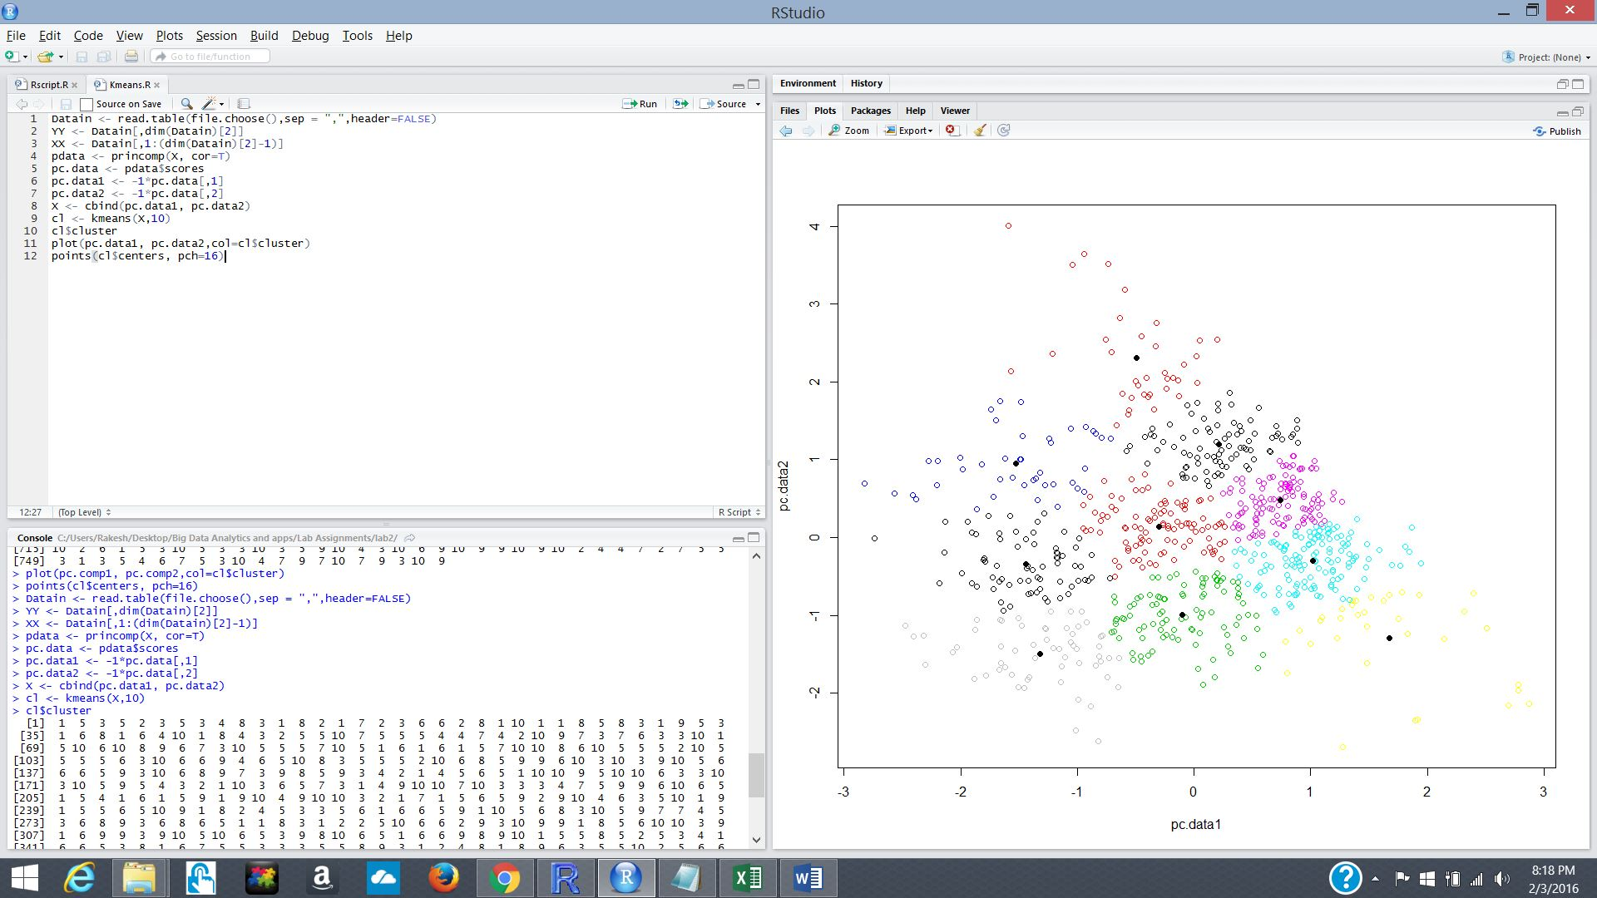

2. Write the R script in R studio.

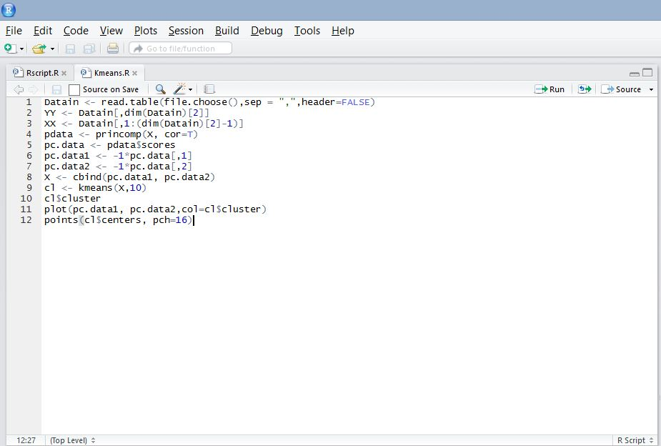

3. See the cluster output in R console using command Cluster

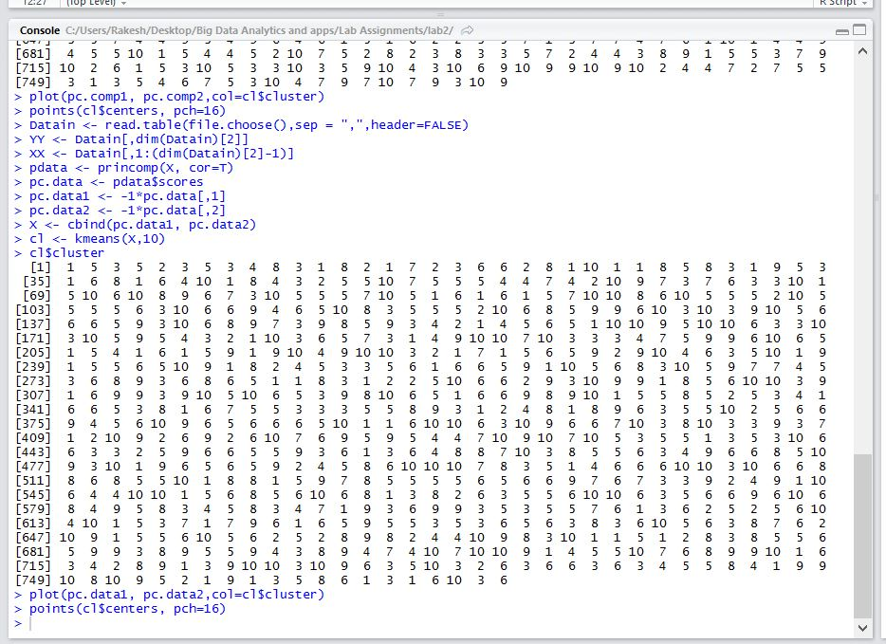

4. Graph of cluster output with 10 clusters and Dark black dots indicate the centroid of means of cluster.

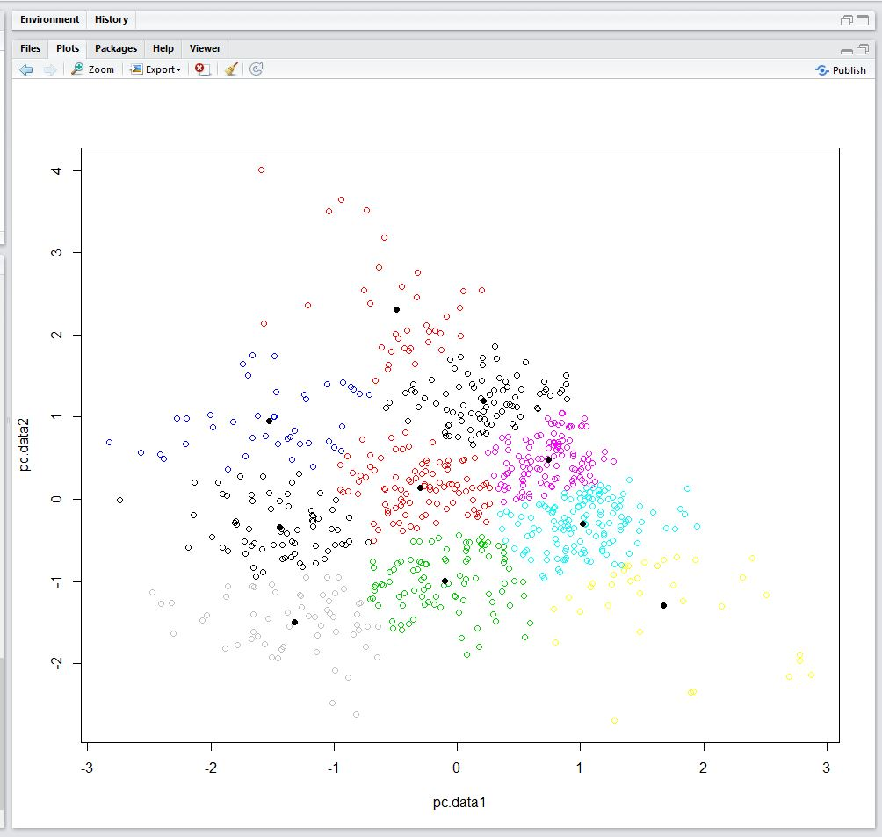

**2. ROBOME AND SMART WATCH APP**

In the Robome phone, the application output. This application sends temperature outside based on the latitude and longitude of the Robot to the Smart watch.

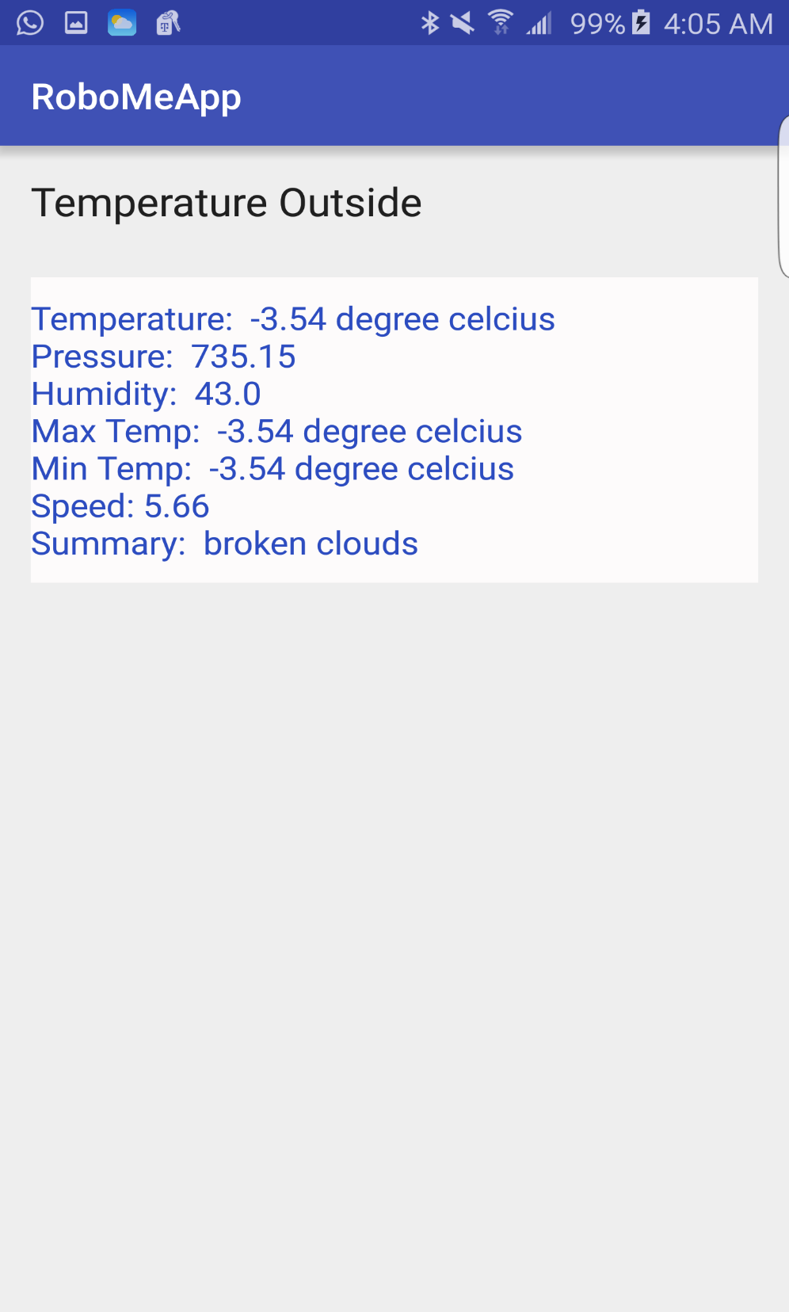

**Android wear side:**

The android wear application is used to connect the phone and smart watch.

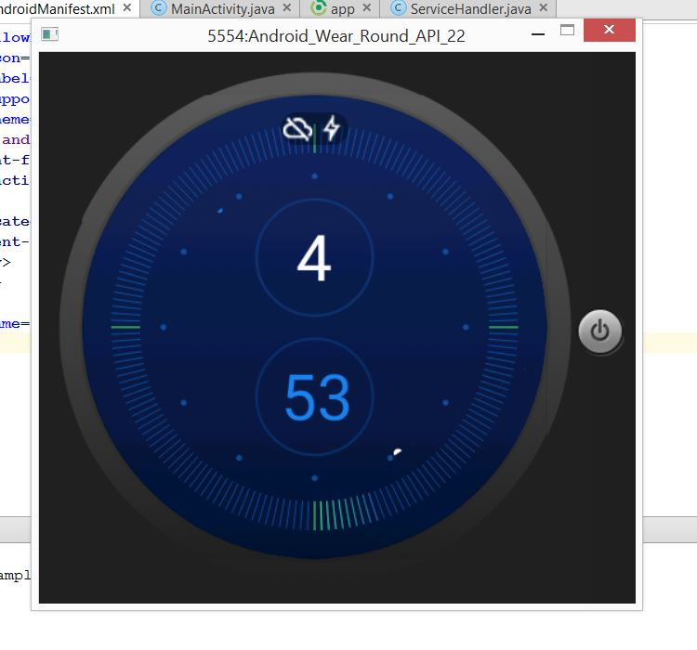

**Can see the temperature on smart watch running on device.**

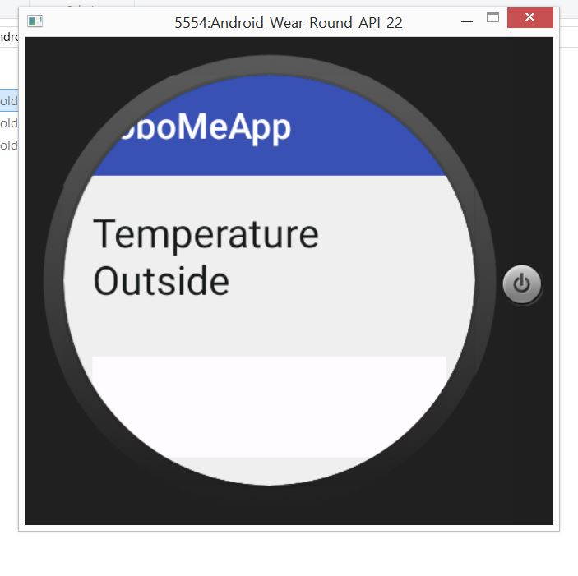

This is android speech to text application in android wear which is used to send request to android phone.

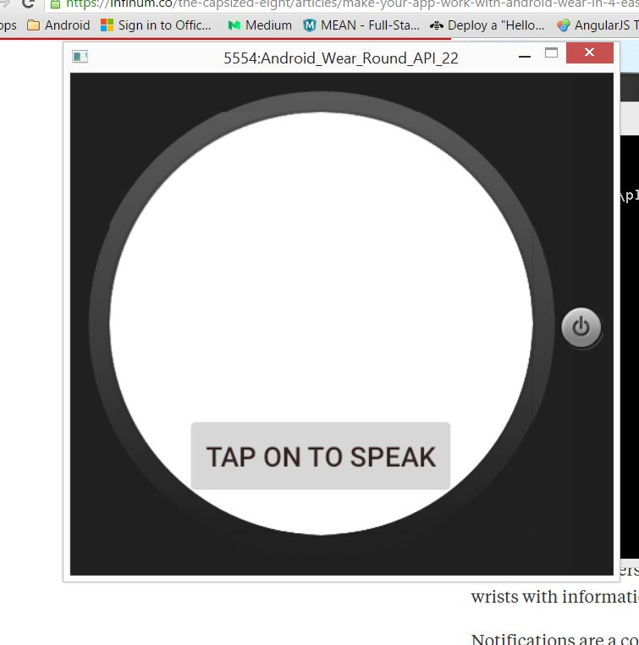

Here speak something example: Know the location temperature.

